FASHION
BUSINESS PARTNERSHIP
Trade Day: March 16-19, 2009
Venue: ICC International Plc. Building, Bangkok, Thailand

Fair Information
Event Name : | FASHION BUSINESS PARTNERSHIP  : SPRING / SUMMER 2010 & BEYOND
Duration : | Trade days : 16-19 March 2009 ( 9.00-17.00 hrs. )
Venue : | ICC International Plc. Building, 6th floor, Bangkok, Thailand
Organizer : | SAHA GROUP TEXTILE & FASHION BUSINESS CENTER  757/10 Soi Pradoo 1 Sathupradith Rd. Bangpongpang, Yannawa, Bangkok 10120  * MR. WORATHEP ASSAVAKASEM * MR. SUSUMU MIYAMOTO  Tel. (66) 0-2294-3767 Tel. (66) 0-2683-8014  Mobile. (66) 087-038-8855 Mobile. (66) 081-373-3218  E-mail: worathep_ass@icc.co.th E-mail: miyamoto2550spi@yahoo.co.jp
Co-Organizer: | - ITOCHU (THAILAND) LTD.  - MARUBENI THAILAND CO., LTD.  - MITSUBISHI COMPANY (THAILAND) LTD.  - MITSUI & CO. (THAILAND) LTD.  - I.C.C. INTERNATIONAL PLC.  - SAHA PATHANA INTER-HOLDING PLC.
Official Hotels :  (If require please contact) | Contact Persons E-mail Mobile
  Mr.Worathep Assavakasem | worathep_ass@icc.co.th | (66) 087-038-8855
  Mr. Susumu Miyamoto | miyamoto2550spi@yahoo.co.jp | (66) 081-373-3218
  Mr. Toshihiro Horai | toshi@icc.co.th | (66) 081-844-8078
  Tel. (66) 0-2294-3767 | Fax. (66) 0-2294-9543
Exhibitor Profile : | Sourcing From First to Finish :  Fiber to Fabric ,  Apparel Manufacturer from OEM to ODM ,  Cover all age groups – Men , Women , Baby & Children  Innerwear / Outerwear  Uniforms Service :  Fiber to Fabric ,  Apparel Manufacturer from OEM to ODM ,  Uniforms Category: Airline / Bank & Finance/ Hotels/ Restaurant/ Retail Services/ Prep School/ Office’s wear/ Workwear  Leather Fashion :  All bags for fashion Dress-up , At work , Party & Leisure including Traveling  Made of Leather & other materials  Socks & Trend :  Business Men’s Socks (Links, Rib, Jacquard )  Casual Men’s Socks (Links, Rib)  Ladies Socks
Number of Exhibitors : | 18 Companies  Garment Makers :  - BANGKOK TOKYO SOCKS CO., LTD  - CHAMP ACE CO., LTD  - FIVE STARS PLUS CO., LTD  - PATTAYA MANUFACTORING CO., LTD  - PEOPLE’S GARMENT PLC.  - S. APPAREL CO., LTD  - SUNRISE GARMENT CO., LTD  - THAI GUNZE CO., LTD  - THAI ITOKIN CO., LTD  - THAI TAKAYA CO., LTD  - THAI WACOAL PLC.  - THANULUX PLC.  - TOTAL WAY IMAGE CO., LTD  Textile Makers :  - ERAWAN TEXTILE CO., LTD  - GRAND STAR INDUSTRY CO., LTD  - PEOPLE’S GARMENT PLC.  - SSDC (TIGERTEX) CO., LTD  - TEXTILE PRESTIGE PLC.  - THAI SHIKIBO CO., LTD
Exclusive Service : | Japan Market Focus :  ‘Exclusive Trade Mission’  for Japanese Fashion Business
Visitor Profile : | Buyers , Importers , Trading Firm ,Garment Makers , Fabric Makers , Distributors, Wholesalers, Retailer in Fashion business,  Trade association Organizations ( Japan , Thailand ),  The Federation of Thai Industries,  Royal Thai Government – Department of Export Promotion, Ministry of Commerce
Venue
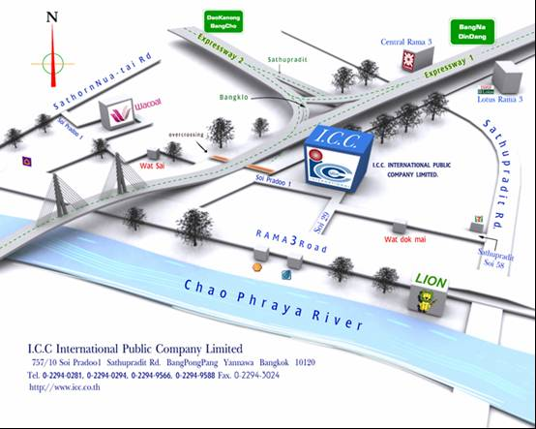
For Taxi:
สำหรับแท๊กซี่
บริษัท ไอ.ซี.ซี. อินเตอร์เนชัลแนล จำกัด (มหาชน )
757 /10 ซอยประดู่ 1 ถนนสาธุประดิษฐ์ บางโพงพาง ยานนาวา กรุงเทพฯ
โทร. (66) 0-2294-3767 มือถือ. (66) 087-038-8855

